Introduction
Using relational operators and logic operators, we can build boolean expressions, which allow us to ask questions within our program – is the balance greater than 0? is the age less than 21? is the user already registered? These expressions can be used in if statements and while loops in order to execute portions of code if the statement is true.

Information

Boolean Expressions
A boolean expression is an expression that results in either true or false. For example:
- Is x greater than y?
- Is grade less than 70?
- Are width and length equal, and is length and height equal?

To write these statements in code, we use the relational operators. To ask more than one question at a time, we combine boolean expressions with logic operators.

Visual Representations
Boolean Expression | Representation
x == y  is x and y equal? | 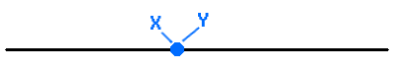
x != y  is x and y not equal? | 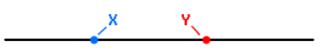
x <= y  is x less than or equal to y? | 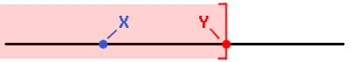
x < y  is x less than to y? | 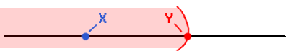
X < 0 || x > 10  True: x is less than 0, or greater than 10, exclusive.  False: x is between 0 and 10, inclusive. |   An OR is the appropriate way to represent this. AND is incorrect, as x cannot be both less than 0 AND greater than 10.
X >= 0 && x <= 10  True: x is between 0 and 10, inclusive.  False: x is less than 0, or greater than 10, exclusive | 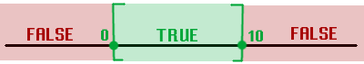

Truth Tables
We can use truth tables to diagram out all possible results of a conditional statement. For example:
X >= 0
True
False
In this case, we're asking the question, “is X greater than or equal to 0?” and there can only be two outcomes: true or false. If X happens to be 5, then the result will be true. If X is -2, then it will be false. But the specific values of X we don't care about, we only care about the states: True or False will be returned from the conditional statement.

From there, we can analyze more complex statements by viewing all possible states. If we have two conditions: X >= 0 AND X <= 0, then there can be four possible states:
X >= 0 | X <= 0
True | True
True | False
False | True
False | False

They can both be true, they can both be false, or we could have some combination of one true and one false. In the table above, we're analyzing these two statements independently of each other: X >= 0 isn't going to affect the result of X <= 0, but if we're looking at both of them together, we can at least diagram out all possible “states”.
From this, we can fill out a full truth table for a more complex statement, like asking if:
X >= 0 AND X <= 0
X >= 0 | X <= 0 | X >= 0 AND X <= 0
True | True | True
True | False | False
False | True | False
False | False | False

The only way we get the result of TRUE is if both sub-statements are true.
We can represent simple AND and OR statements in a more generic sense, using “A” and “B” as questions:
  A | B | A and B
  True | True | True
  True | False | False
  False | True | False
  False | False | False
  A | B | A or B
  True | True | True
  True | False | True
  False | True | True
  False | False | False

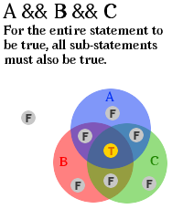 | AND statements  - If all sub-questions are true, then the entire statement is true.  - If any sub-questions are false, then the entire statement is false.
  A | B | A and B
  True | True | True
  True | False | False
  False | True | False
  False | False | False
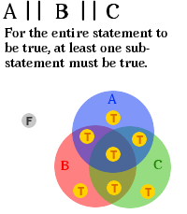 | OR statements  - If any sub-questions are true, then the entire statement is true.  - If all sub-questions are false, then the entire statement is false.
  A | B | A or B
  True | True | True
  True | False | True
  False | True | True
  False | False | False

Lab Questions
Fill in the following truth tables
1.  We don't care about the values of  A, B, or C, we are just asking the question “Is A less than B, AND is B less than C?”.
  A < B | B < C | A < B && B < C
  T
  T
  F
  F
2.  Here, think of “StateIsKansas” and “StateIsMissouri” as boolean variables, which can be assigned to either “true” or “false”.
  StateIsKansas | StateIsMissouri | StateIsKansas OR  StateIsMissouri
  T
  T
  F
  F
3.

A | B | C | A && B | (A && B) || C
T | T | T
T | T | F | T | T
T | F | T
T | F | F
F | T | T
F | T | F
F | F | T | F | T
F | F | F

